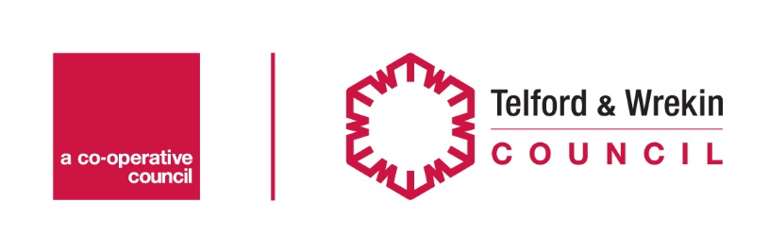

Business Flood Recovery Grant for business premises
This grant relates to Small and medium sized businesses which:
- Were directly impacted by the flooding in February 2020 – for instance there was flood damage to the property, equipment, and/or stock; or;
- Were indirectly impacted by the flooding in February 2020 – for instance the business has had no/highly restricted access to premises, equipment and/or stock as a result of flooding, restricted access for customers, suppliers and/or staff; and directly suffered a loss of trade as a result.
Only one claim is allowed per business*. Procedures are in place to prevent fraudulent claims being made.
The grant of up to £2,500 is available subject to evidence of the value of the impact which is not covered by insurance. If your application is successful, the council will pay the maximum available to each business.
This is not a compensation scheme. It is of a discretionary nature and is subject to the availability of funding.
The decision of the grant panel is final and it reserves the right to vary the level of grant or reject an application.
The deadline for applications is Friday 20th March.

Contact name Required

Address
Please provide your full business address, including postcode.
Address Required

Preferred contact number
Email address

Business details
An SME (Small and medium-sized enterprises) is defined as a business having no more than 249 employees AND either a turnover of less than €50M (£42.85M) or a balance sheet of less than €43M (£36.85M). A business that is part of a larger group will need to include staff headcount / turnover / balance sheet data from that group too. To view the formal definition please click the link.
Confirmation of business size Required
I confirm that the business is an SME as defined above
Company status Required

Other
*Other Details Required

If Ltd Company or Limited Liability Partnership please give registered office address:
Registered office

Company registration number
If applicable
VAT registration number
If applicable
Is the company part of a bigger group, please provide details:

Are you landlord, owner-occupier or tenant? Required

Flood details
Date of the flooding Required

How was your business impacted by the flooding? Please tick the appropriate box Required
Directly impacted e.g. flood damage to the property, equipment and/or stock ☐
Indirectly impacted e.g. the business has had no/highly restricted access to premises, equipment and/or stock as a result of flooding, restricted access for customers, suppliers and or staff ☐

Please explain what uninsured loss, loss of income or damage your business has experienced Required

Where possible, please provide photos of the damage or any relevant documents (e.g. insurance documents, receipts for immediate and urgent work, cancelled bookings, salary bill for clean-up, takings this years vs last year etc) to evidence loss of earning and costs incurred. Evidence to be supplied by email when returning this form. Required
How long do you consider your business has or will be impacted? Required

What insurance do you have? Required
Buildings
Contents
Floods
Business Interruption
None
Please explain your insurance circumstances

If you would like any advice on business continuity, please tick
Yes

Bank Details: please provide bank details for the transfer of grant if approved:

Account Name:
Account Number:
Sort Code:

Declaration
- Telford & Wrekin Council is the Data Controller under data protection law and will use the information you provide on this form in order to administer the Business Flood Recovery Grant scheme. The legal basis for processing this data is that it is necessary for the performance of a contract with you.
- You will respond to Telford & Wrekin Council regarding any points of clarification raised as a consequence of this application should they be required.
- The statements, information you have provided in support of this application are accurate and true.
- Telford & Wrekin Council reserves the right to reclaim any money, which has been paid as a result of fraudulent or misleading claims and will seek recovery of all costs and interest and will pursue action for attempted misuse of public funds if appropriate.
- Telford & Wrekin Council will keep your data for 6 years, in accordance with the requirements of grant schemes.
- Your information will be cross-referenced with data secured on the extent and observed impact of the flooding across the county area and in assessing this application, you agree to this information being shared with agencies involved as may be required and the Environment Agency.
- Individuals have a number of rights under data protection law, including the right to request their information. You also have a right to make a complaint about our handling of your personal data to the Information Commissioner’s Office.
- Information you provide will only be used for the stated purpose. Further information about the processing of your data can be found on our website. You can contact the council’s Data Protection Officer, Robert Montgomery by email Robert.Montgomery@telford.gov.uk
- Sign declaration Required
I have read and agree the declaration

Date Required
Insert Date:

Once completed please email this form with the associated supporting evidence to: Mark.Shaw@telford.gov.uk and Kathy.Mulholland@telford.gov.uk

